Name _____________________________Date ______________________________Grade 8 Science Group ________________
FRICTION
Answer the following questions completely.
- Why is it easy to slip when there is water on the floor? ___________________________________________________________________________________________________________________________________________________________________________
- Explain why friction occurs. ___________________________________________________________________________________________________________________________________________________________________________
- Describe how the amount of force pushing two surfaces together affect the friction between the surfaces. ___________________________________________________________________________________________________________________________________________________________________________
- Why do you think the sponge shown below has a layer of plastic bristles attached to it?
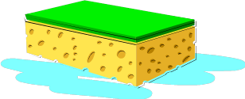
______________________________________________________________________________________
______________________________________________________________________________________
______________________________________________________________________________________

- Name two ways that friction is harmful and two ways that friction is helpful to you when riding a bicycle. __________________________________________________________________________________________________________________________________________________________________________________________________________________________________________________________________
______________________________________________________________________________________

- Describe a situation in which static friction is helpful. ____________________________________________________________________________________________________________________________________________________________________________

7. A new car company wants to improve the performance of their disk brakes. Disc brakes work by applying pressure from the brake pads in the caliper to the rotor (disc) to create friction that slows the car down.
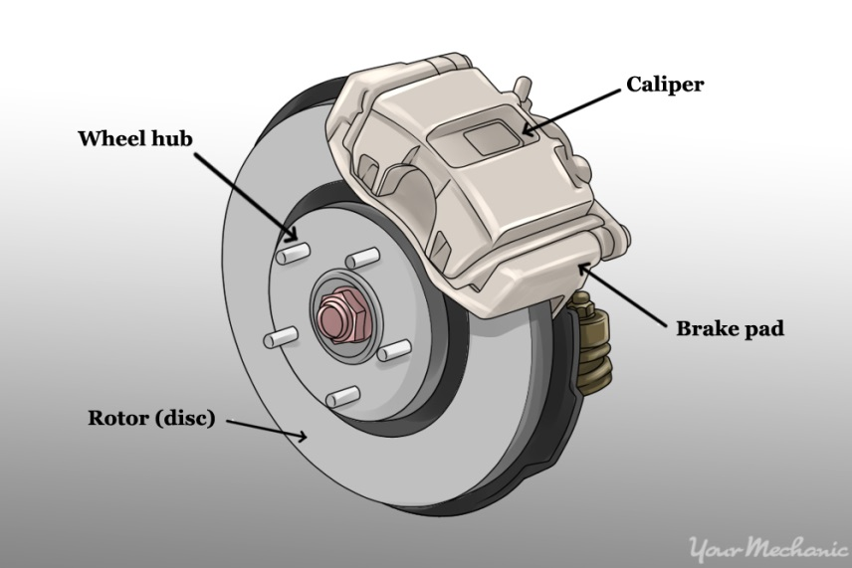
What is a way the car company should explore to increase friction between the rotor and brake pad?
- Make the rotor and brake pads as smooth as possible.
- Engineer microscopic ridges into the rotors and pads that increase roughness between the two.
- Engineer a way to spray oil onto the brake pads and rotors so they can slide easier.
- Decrease the pressure that the caliper applies to push the brake pad onto the rotor.

